AlgoRhythmia
Version 4.1
© 2005-2016 Zeta Centauri, Inc.

AlgoRhythmia generates editable random drum patterns and plays them via MIDI and wave sample playback. It supports 8 channels (8 different drums) and has built-in sound effects. Generated beats can be saved to MIDI or to AlgoRhythmia’s own file format.

Although AlgoRhythmia is meant to be used with drum samples, some musicians have reported interesting results when using ambient synth sounds or other samples.

We encourage you to experiment and play around with the settings. AlgoRhythmia is a creative tool, not just a drum machine.

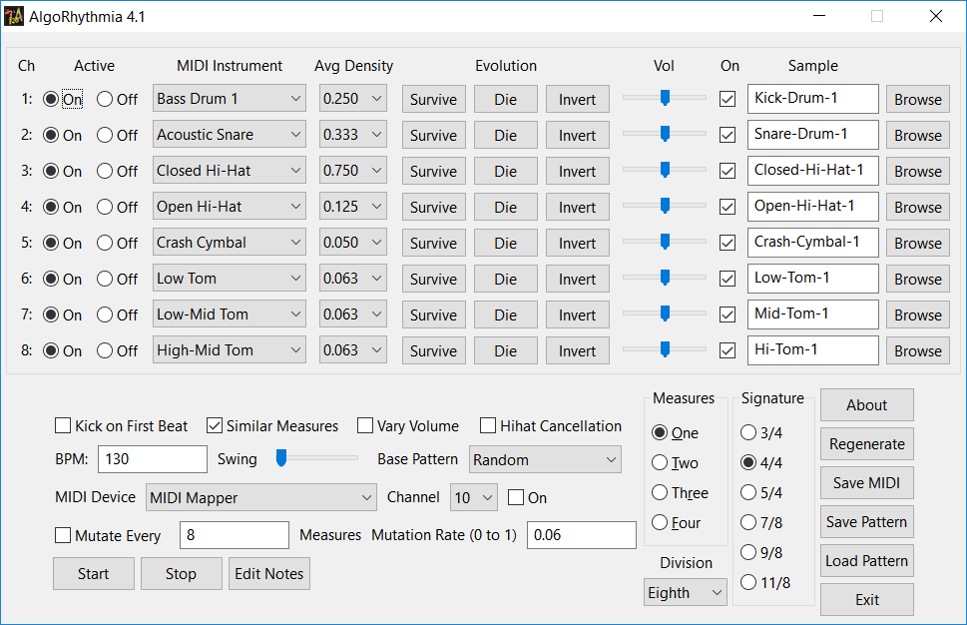
Per-Channel Drum Settings

Ch: Shows the channel number for that line.

Active: Controls whether that piece of the drum kit is active. This can be changed while the beat is playing.

MIDI Instrument: Lets you select which general MIDI drum note to transmit when that drum is triggered (if MIDI output is turned on).

Avg Density: Used to determine on average how often that piece of the drum kit will sound in a new beat generated by either “Die” or “Regenerate”.

Survive: Takes the current pattern for that piece of the kit and mutates it by the factor set in the mutation rate box.

Die: Kills the drum’s pattern and generates a new one.

Invert: Reverses the drum’s pattern, causing it to stop triggering where it was before and start triggering everywhere it wasn’t.

Vol: Allows you to adjust the volume of the sample.

FX: Shows the effects edit window, which allows you to add, change, and remove effects processing from the sample for that drum channel. Each channel can have different effects, allowing you to thoroughly customize the sound of your drums. Effects are only available for channel #1 in the demo version.

On: This controls whether sample playback is turned on for the channel.

Sample: This shows the wave file that is currently set to trigger for the channel.

Browse: Lets you browse for a different sample to play for that channel. The full version of AlgoRhythmia 4 includes a set of 100 royalty-free drum samples that can be freely used in any of your music. You can also load any other wave-format samples you may have.

Other Settings

These controls include beat generation parameters and MIDI output settings.

Kick on First Beat: This will cause the kick drum to play on the first beat of a measure, even if the kick drum is not turned on.

Similar Measures: In patterns greater than one measure in length, this will cause subsequent measures to be mutated copies of the first measure (based on the mutation rate). Only has an effect if “Die” or “Regenerate” is used.

Vary Volume: This causes drums to be triggered with slight variances in MIDI volume. This affects both MIDI and sample volume. This is a subtle effect and may not be noticed, but should serve to “humanize” the drumbeat ever so slightly.

Hihat Cancellation: Prevents a closed and open hi-hat sound from playing at the same time. The hi-hat to take precedence will be the one with the lowest channel number. This allows you to have an open, pedal, or closed hi-hat to take precedence based on the channel it is set to. If this is enabled, all hi-hats beyond the first one to sound on a particular beat will not be triggered. This can lead to interesting results if the MIDI notes are set to hi-hat types but the wave samples are set to other sound effects.

BPM: This sets the number of beats per minute.

Swing: This setting lets you set the amount of “swing” in the drum pattern.

Base Pattern: This lets you select different basic beats to start with when the “Regenerate” button is pressed. “Random” is the default and will cause a random drumbeat to be generated. “Clear” will clear all drum triggers. The other items will generate various standard drum patterns (i.e. rock, funk, et cetera).

MIDI Device: This lets you select which sound device will be used for MIDI playback. The default device is the MIDI Mapper – which plays through the device selected for MIDI Playback in the Windows control panel.

Channel: This lets you select which channel to use for transmitting MIDI data.

On: This checkbox lets you turn MIDI output on or off. It is off by default to avoid the ugly clashing sound of samples and the default MIDI Mapper playing at the same time.

Mutate Every X Measures: This has two components – a checkbox to enable or disable mutation and a text box that lets you set the number of measures to play before mutating using the setting in the Mutation Rate box. Be sure to read the note under the “Edit Notes” entry.

Mutation Rate: Lets you set the rate of mutation for a beat. This should be from 0 to 1. It is a percentage expressed as a decimal value and is used for mutation calculations in the “Survive” button and “Mutate every X measures” setting, in addition to being used when regenerating a random drum pattern with “Similar Measures” selected. A setting of 0.06 is a mutation rate of 6%.

Start: Starts playback of the current beat.

Stop: Stops playback.

Edit Notes: Shows the drum grid so you can edit the current drum pattern.

Note: We recommend leaving the drum grid hidden while the beat is playing when “Mutate Every X Measures” is enabled because slower systems may have trouble keeping up. (Windows element updates are notoriously slow, and updating 700+ checkboxes could cause it to skip or drop a beat during play).

Measures: Lets you set how many measures long the generated pattern will be. This combined with the time signature determines the overall length.

Division: Lets you select the note division that each checkbox on the Edit Notes represents. The default is eighth notes, but you can use quarter or sixteenth notes for finer or coarser pattern edit resolution.

Signature: Lets you set the time signature for the pattern. Individual beats are not emphasized, so this just determines the length of the pattern.

About: Shows version and author information.

Regenerate: Clears all drum patterns and generates a new beat based on the settings in the average density boxes.

Save MIDI: Lets you save the current pattern to a MIDI file. This can be handy for importing into your favorite sequencing or looping application, or just for keeping the beat to listen or play along to later.

Save Pattern: Lets you save the current AlgoRhythmia settings as an XML file. There are over 1100 settings and pieces of data that go into producing a pattern, so saving is a good idea if you’ve come up with something you like.

Load Pattern: Lets you load AlgoRhythmia settings from an XML file.

Exit: Exits the program. Settings will not automatically be saved, so you may want to click “Save Pattern” before exiting if you want to keep your work.

Drum Edit Grid

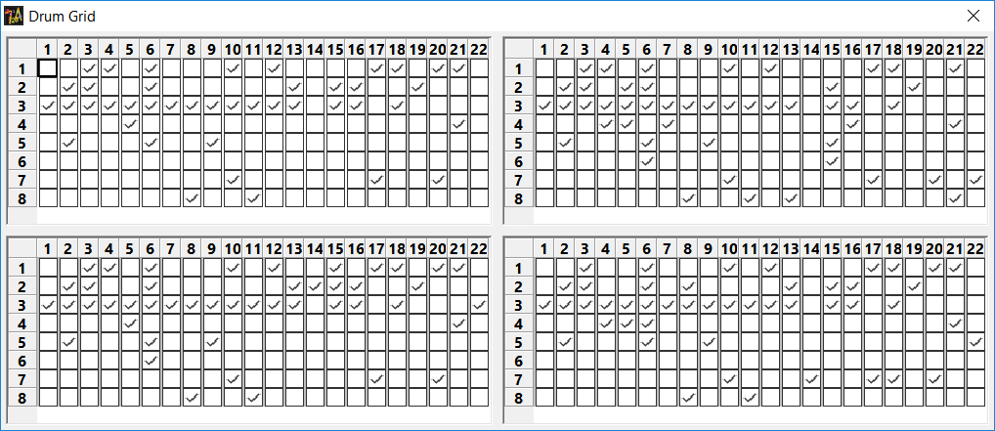
The drum edit grid lets you turn a drum on or off for a particular beat. Unused beats, measures, and drums will be grayed out and will not sound while AlgoRhythmia is playing. You can edit grayed checkboxes, but they will not be heard. They will, however, save with the pattern info when you save a pattern to disk.

To turn on/off a drum, click the check box for the channel/beat combination you wish to change.

Changes

Changes from AlgoRhythmia Version 4 to 4.1:

1) Replaced entire sample set for a total of 100 samples and changed default starting sounds.
2) Updated libsndfile and wxWidgets libraries.
3) Added General MIDI Level 2 drum notes to MIDI note list.
4) Bug fixes in pattern save and load.

Changes from AlgoRhythmia Version 3 to 4:

1) Replaced the DirectMusic sound generation engine with XAudio2. DirectMusic
is no longer supported by Microsoft and does not work on 64-bit systems.
AlgoRhythmia 4 now works on 64-bit Windows.
2) User interface was modified to properly handle the 125% zoom level on Windows
7 and Vista.
3) Added more samples to the full version.

Changes version 2 to 3:

1) Added Clear, Fibonacci, Sierpinski, and Sierpinski inverted, Basic Rock, Basic Rock 2, Basic Rock 3, Funk, and Oontz to base pattern list.
2) Converted application to use wxWidgets.
3) Kick sample (first sample) also plays when 'kick on first beat' is selected.
4) *Added save and load of settings.
5) *Added ability to edit individual drum notes on a grid.
6) Added swing setting.
7) Added volume setting for individual samples which affects both MIDI and sample volume.
8) *Added 58 samples recorded from the Yamaha TG-55 tone generator.
9) Now accepts mutation rate values of 0.
10)*Added ability to save to MIDI.
11)**Added 8 different effect types: Chorus, compression, distortion, echo, flange, gargle, parametric eq, and reverb.
12)Added on-off checkbox for MIDI.
13)Added hi-hat cancellation.
14)Improved tab order so that editing settings via keyboard is feasible.
* = Not available in demo version.
** = Only available for channel #1 in the demo version.

Version 1 to 2:
1. Added invert buttons.
2. Changed from fixed drum sounds to user-selectable drum sounds.
3. Switched to a multithreaded model so that changes could be made
to settings without causing playback to stop or stutter.
4. Added .wav sample playback.
5. Added ability to select MIDI channel and device.
6. Added mutation every X bars.
7. Added ability to vary volume to make pattern sound vaguely more "Human".

All constructive feedback is welcome. If you have an idea how this program can be improved or a feature you would like to see, feel free to contact jchampion@zetacentauri.com. Feel free to visit our website at http://zetacentauri.com for new product information, downloads, and product forums.

